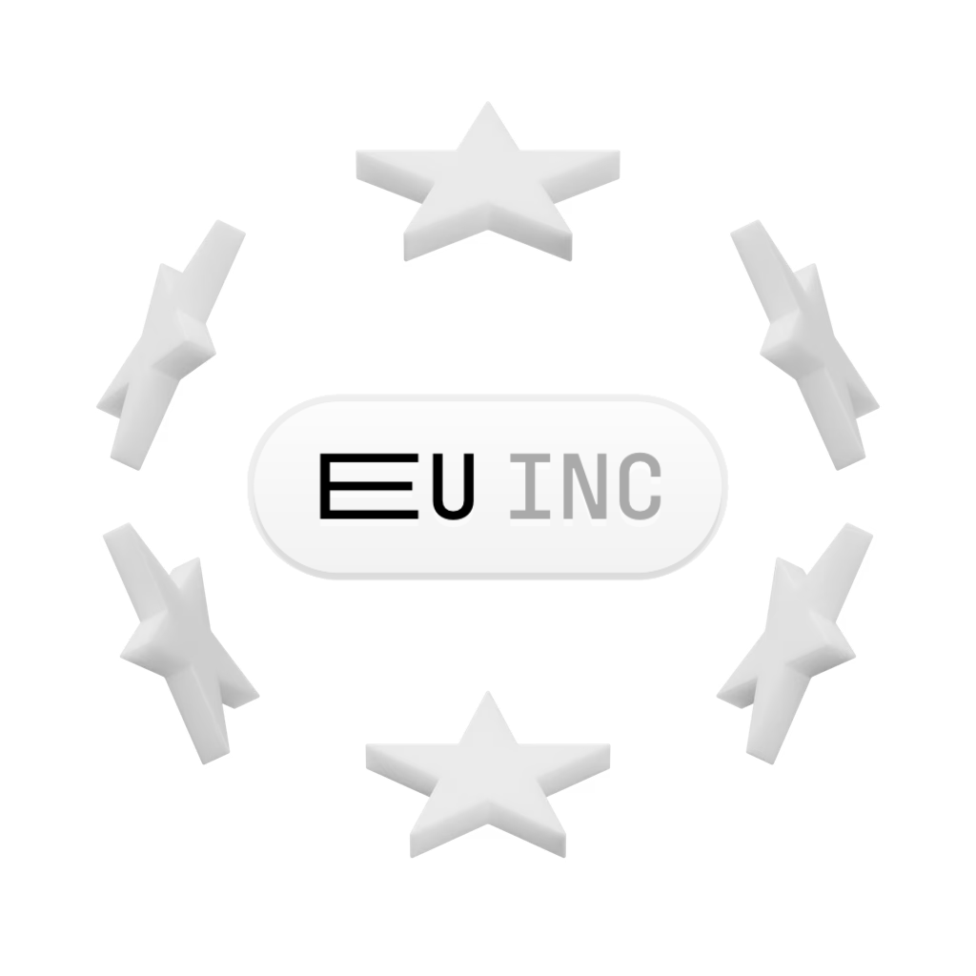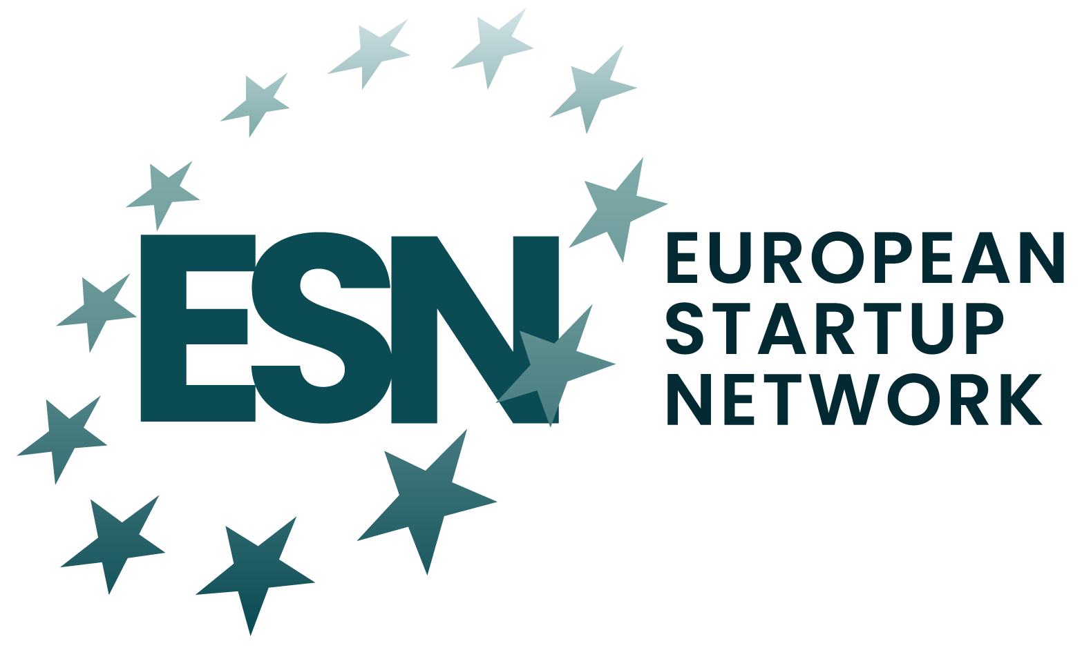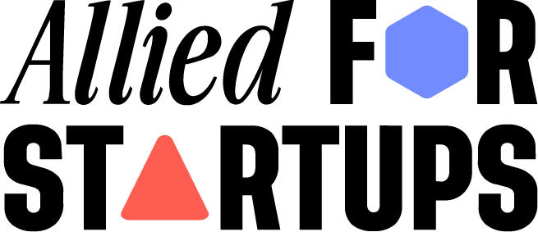

**Half-Measures Never Built a Champion**

Joint Statement: MEP Repasi Report on the 28th Regime

15 July 2025

| A fragmented Single Market costs the EU €1.3 trillion every year, limiting Europe’s ability to grow new internationally competitive companies.  Bold reform is now needed. By replacing the 27 separate national incorporation regimes with a single, unified system that will allow for the next generation of European companies to scale and succeed.  While the ESSU proposal claims to address this challenge, in reality it preserves the same national legal fragmentation that continues to hold Europe back.  **Key flaws:**   * Uses a Directive, not a Regulation – no uniform rules, no scale * Favours legacy/family businesses over high-growth startups * Overemphasises “killer acquisitions” with outdated logic * Assumes it can prevent relocations, without offering alternatives * Startup voices largely excluded from the process   **What is needed:**   * A true 28th regime with a single, digital EU-wide company form * A simplified, unified system will help startups scale from day one   **Bottom line**: Without bold reform, Europe risks losing talent and global competitiveness. |
| --- |

1. **Context:**

Europe’s social model was built on strong, internationally competitive companies. Twenty-five years ago, 40% of the world’s largest firms were European; today, that share has fallen to just 10%. As global competition has intensified, Europe has slipped behind, weighed down by a fragmented Single Market that costs the EU an estimated €1.3 trillion each year.[1] This fragmentation is now holding back over 35,000 European startups and 3,400 scale-ups.[2] To unlock their full potential, Europe needs a legal framework that genuinely supports their ability to scale across the entire Single Market without unnecessary barriers.

The MEP Repasi [draft report](https://www.europarl.europa.eu/doceo/document/JURI-PR-773199_EN.pdf) on the “28th Regime” for innovative companies aims to address this with the ESSU (European Start-Up and Scale-Up) model, a harmonised but non-autonomous national corporate form. It proposes a framework harmonised at the EU level but rooted in national corporate laws, allowing firms to opt in voluntarily. While aiming to simplify cross-border business, it explicitly rejects the idea of a single, autonomous European company form, instead favouring nationally adapted versions with harmonised elements.

This means that, instead of harmonising and simplifying the current landscape of 27 national company law regimes, the proposal could introduce up to 27 additional ones, further increasing complexity and creating new barriers to scaling across the Single Market.

As a result, the proposal fails to deliver the bold, unified legal framework needed for startups to succeed in Europe. Instead, it reinforces fragmented national systems that add complexity and cost, contradicting repeated calls from the startup ecosystem for a genuine pan-European company form. As long as this fundamental issue remains unaddressed, other regions with large, integrated markets and simpler incorporation processes will continue to draw Europe’s most ambitious founders away while preventing a new generation of entrepreneurs from benefiting from a 'real' 28th regime.

**What is Needed Instead**

What’s needed is meaningful, impactful, and bold reform: a true 28th regime with a single central digital incorporation platform that reduces fragmentation and costs while ensuring equal opportunities for founders across the EU. It would allow existing businesses to re-establish themselves under the 28th Regime and enable investors to conduct just a single due diligence process for the entire bloc, instead of navigating 27 different national versions as they do today. The result would be the elimination of the very barriers that currently push investors to encourage European founders to relocate to other jurisdictions.

As a result, we expect genuine ambition from the European Commission and co-legislators, especially given the Commission’s stated goal of making Europe the best place in the world to start and grow a business. It is time to prioritise the ambitions of European founders by creating one new pan-European, digital-first, legal entity.

1. **Key Critiques of the Proposal**

**Uses a Directive over a Regulation:** The report proposes using a Directive to create the ESSU, but that approach is fundamentally flawed. Only a Regulation can deliver a truly uniform legal framework across all Member States without relying on uneven national implementation, enabling startups from all over Europe to grow and succeed in their home market. A Directive would just preserve the same fragmentation that already undermines European competitiveness and drives founders to incorporate elsewhere. By contrast, a single, directly applicable Regulation would ensure startups can access the same streamlined, predictable company form from day one, eliminating costly legal complexity and making the Single Market genuinely work as one.

**It is not a 28th Regime:** The European Parliament’s proposal cannot be considered a true 28th regime because it does not rely on Article 352 TFEU, the only legal basis that allows the EU to establish an optional, self-standing legal form that exists alongside national company laws. Instead, the Parliament suggests using Articles 50 and 114 TFEU, which are designed to coordinate or harmonise national laws. Without Article 352, the initiative lacks the legal foundation to deliver an optional, directly applicable company form that founders across Europe can voluntarily choose. This makes the proposal not only incompatible with the core demands of the European startup ecosystem but also contradictory to the clear request from EU Member States, who have called on the Commission to put forward a proposal for a 28th regime, nothing else.

**Focus on Saving Outdated Business Models:** The emphasis on features like dual-class shares, veto shares, asset locks, and stewardship models strongly reflects the priorities of mature, often family-owned businesses that want to preserve control and resist hostile acquisitions. But Europe’s future doesn’t lie in protecting traditional family businesses; it depends on high-growth startups who need easy access to venture capital and seamless cross-border scaling. By tailoring this proposal to the needs of the former, it becomes clear that Europe isn’t playing to win. As long as that remains the case, it will continue to fall short of producing the number of innovative global champions it needs.

**Overemphasis on Killer Acquisitions:** By placing an undue emphasis on issues such as “killer acquisitions” without clear supporting evidence, the approach in the report highlights an outdated, industrial-era understanding of how markets and competition work, particularly in the digital sphere. In today's digital economy, competition and substitution aren't about products looking similar or serving identical functions, they're about different ways of satisfying the same underlying consumer needs.

This fundamental misunderstanding risks creating regulatory frameworks that don't align with market realities.

**Preventing Relocations Is Not a Strategy:** While the goal is to have startups stay and succeed in Europe, the report’s focus on “preventing relocations” reflects a deeply misguided approach. Instead of creating the best environment for companies to choose Europe willingly, it implies trying to lock them in by force. This mindset is at odds with the principles of an open, competitive market and sends the wrong message to founders and investors. True competitiveness isn’t about restricting movement but about making Europe the most attractive place to build, grow, and thrive. By prioritising barriers over incentives, the report risks undermining Europe’s appeal as a global hub for innovation and entrepreneurship.

**Lack of Startup Voices:** It’s concerning that among all the organisations consulted for this report, very few represent the startup community, while far more weight appears to have been given to notaries, family business associations, and national interests.[3] This imbalance suggests the proposal is shaped more by those wanting to preserve existing legal complexity than by the needs of founders who hold the key to Europe’s future competitiveness. By failing to prioritise the voices of the very entrepreneurs who can drive growth and innovation, the report risks delivering a framework that is out of touch with the realities of building and scaling a startup in Europe.

1. **Conclusion**

The time for half-measures is over. If Europe wants to compete on the global stage and foster the next generation of world-leading companies, it needs to act with urgency and ambition. The EU must show that it is serious about playing to win by delivering a genuine 28th regime with a single, digital gateway for incorporation that enables startups from all over Europe to found, fund and scale as if the entire Single Market were their home market.

Anything less will leave European founders at a disadvantage, reinforcing the perception that Europe continues to overpromise and underdeliver on its innovation goals. This will deepen the negative narrative that pushes founders to relocate, ultimately keeping Europe on a path toward “slow agony.”[4]

Instead, this moment is an opportunity for the EU to build something bold and ambitious, a true 28th regime with a central digital incorporation platform that reduces fragmentation, attracts investment, and ensures equal opportunities for founders across the EU. This would give the Union a global competitive edge and once again position Europe as a leading hub for innovation.

**Co-signatories:** 

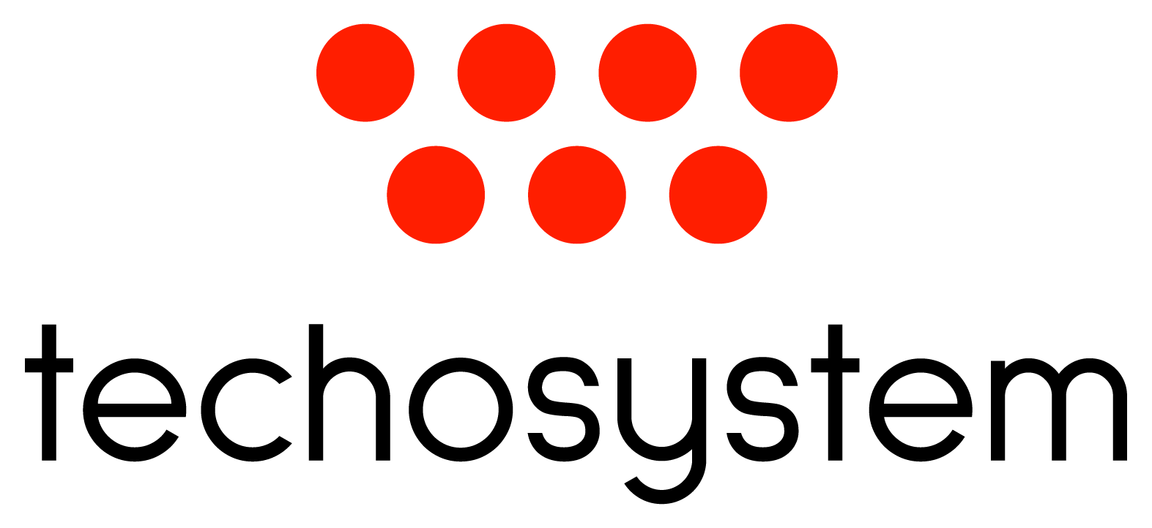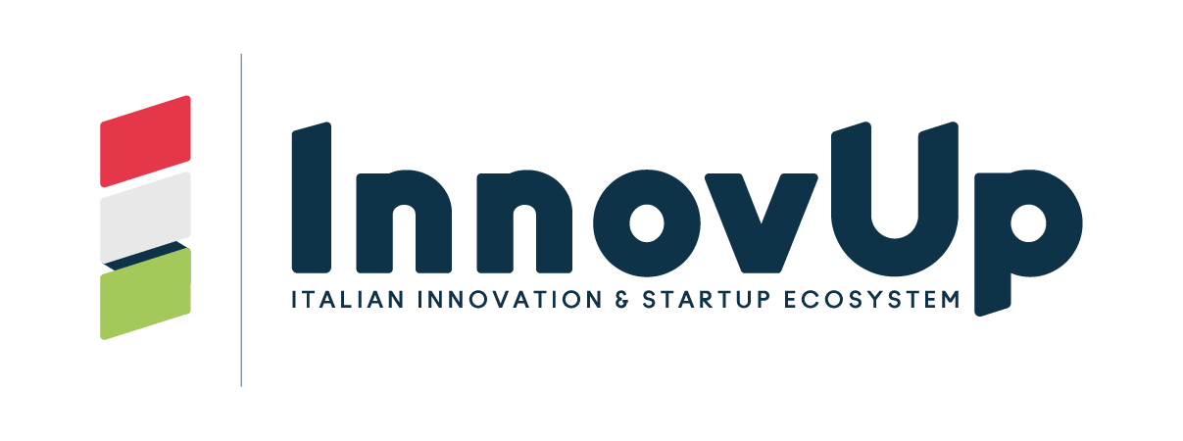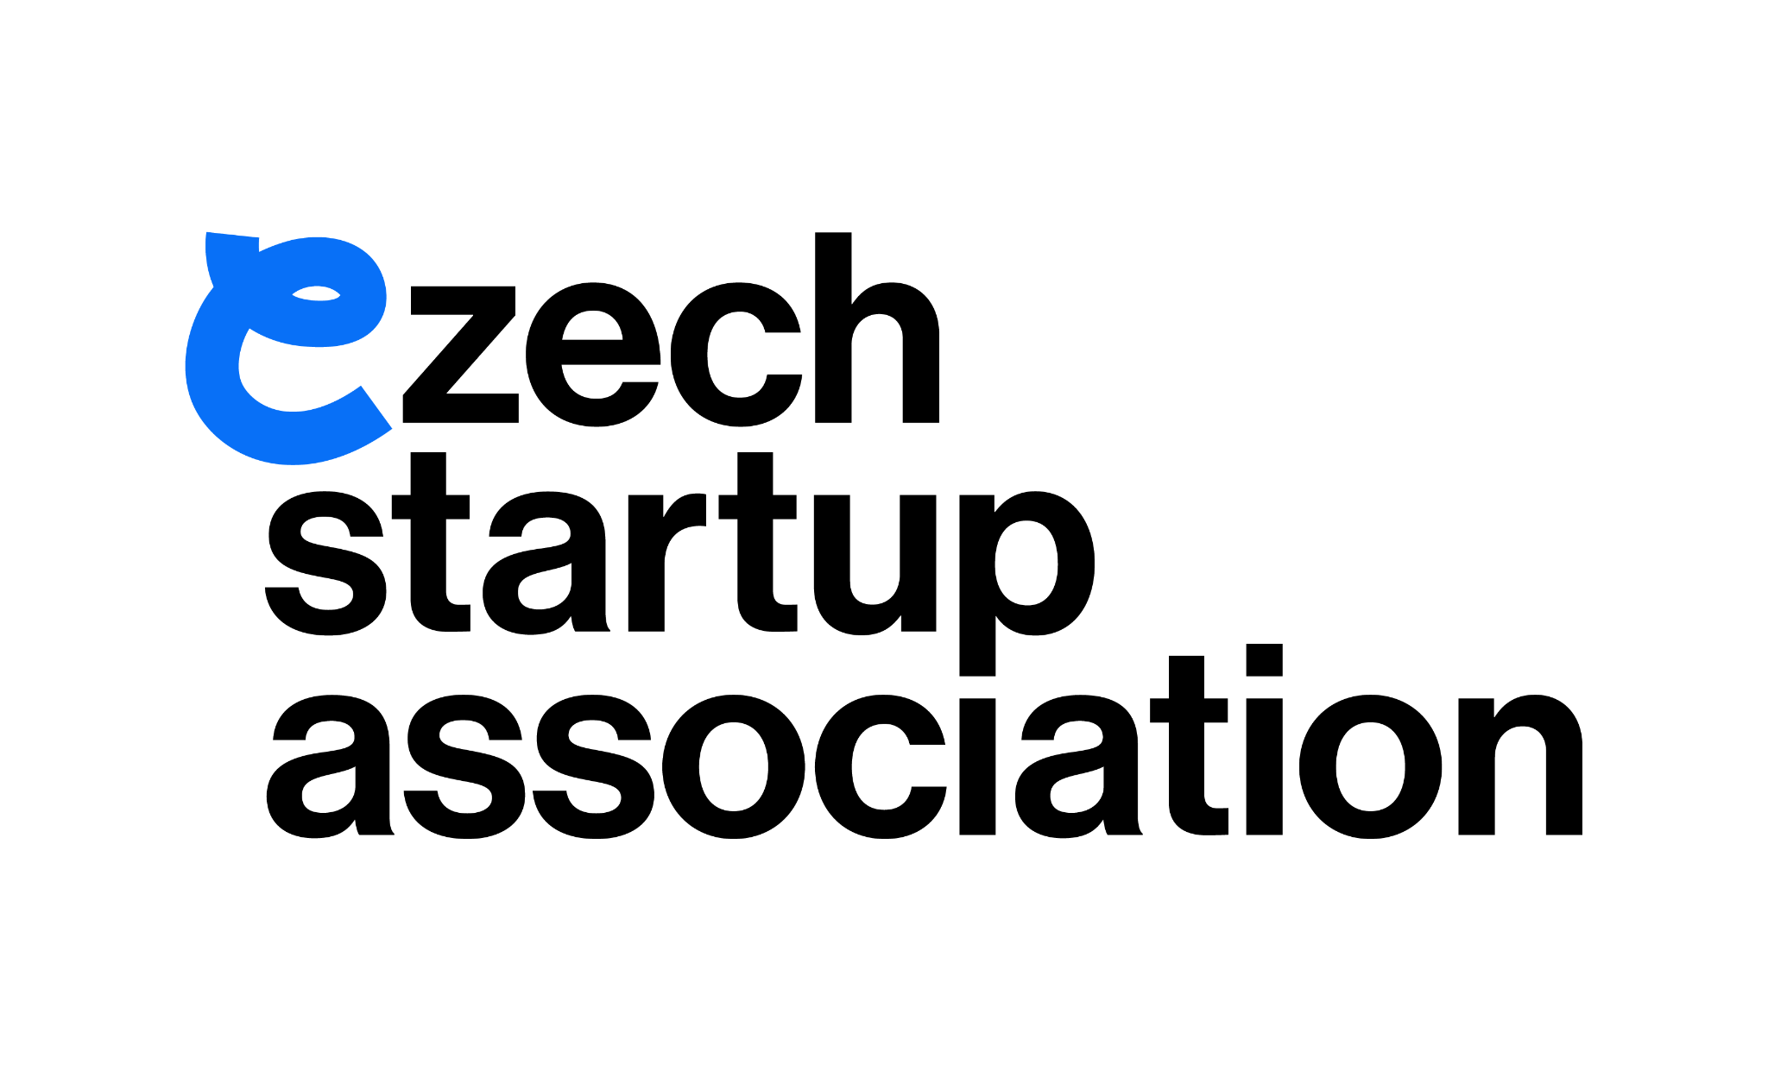

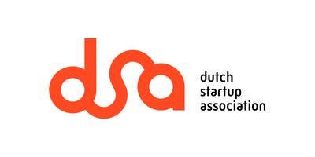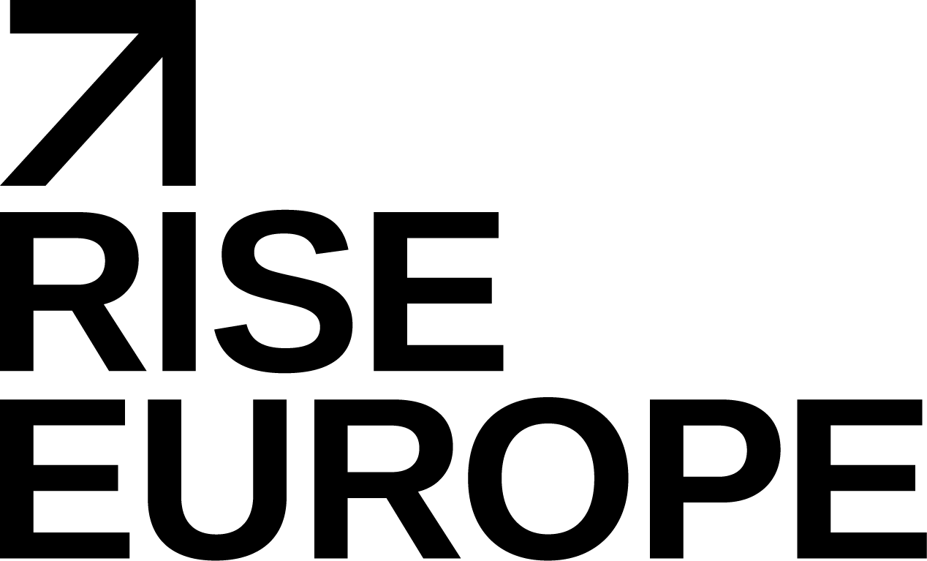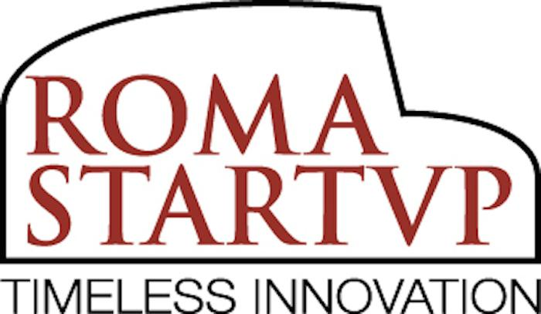

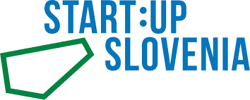





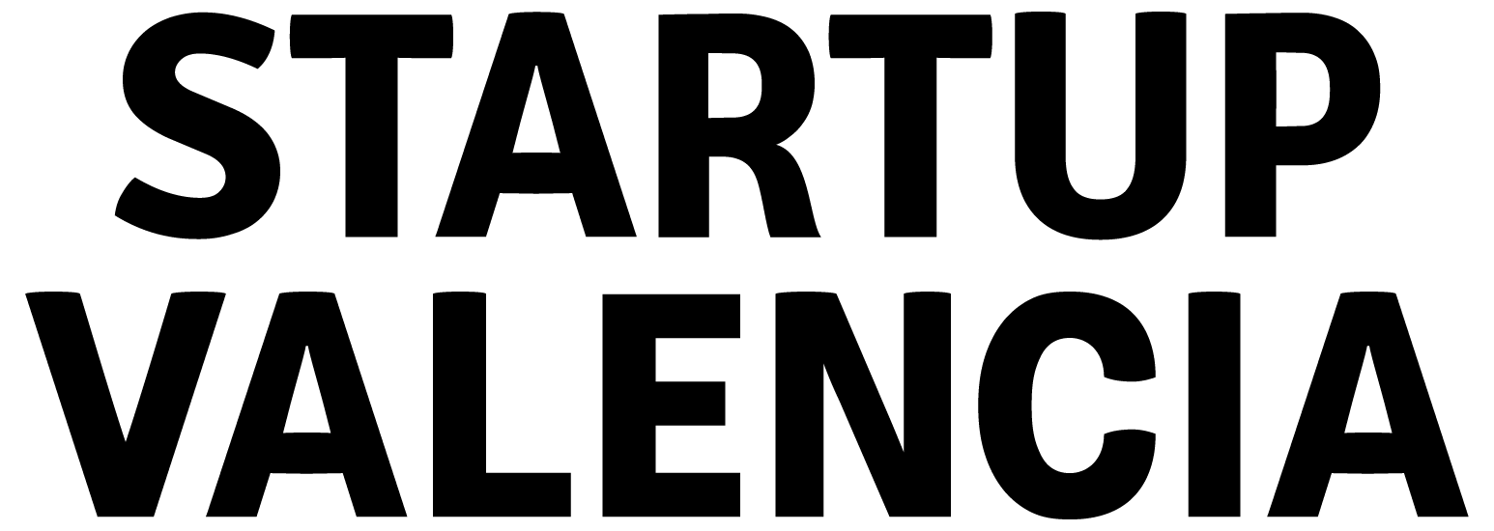

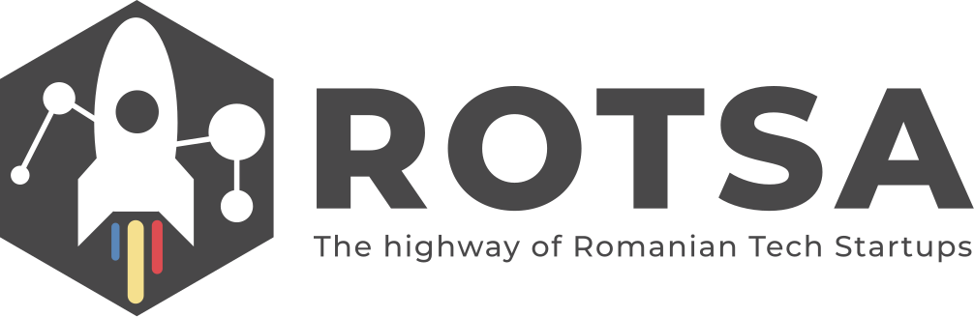



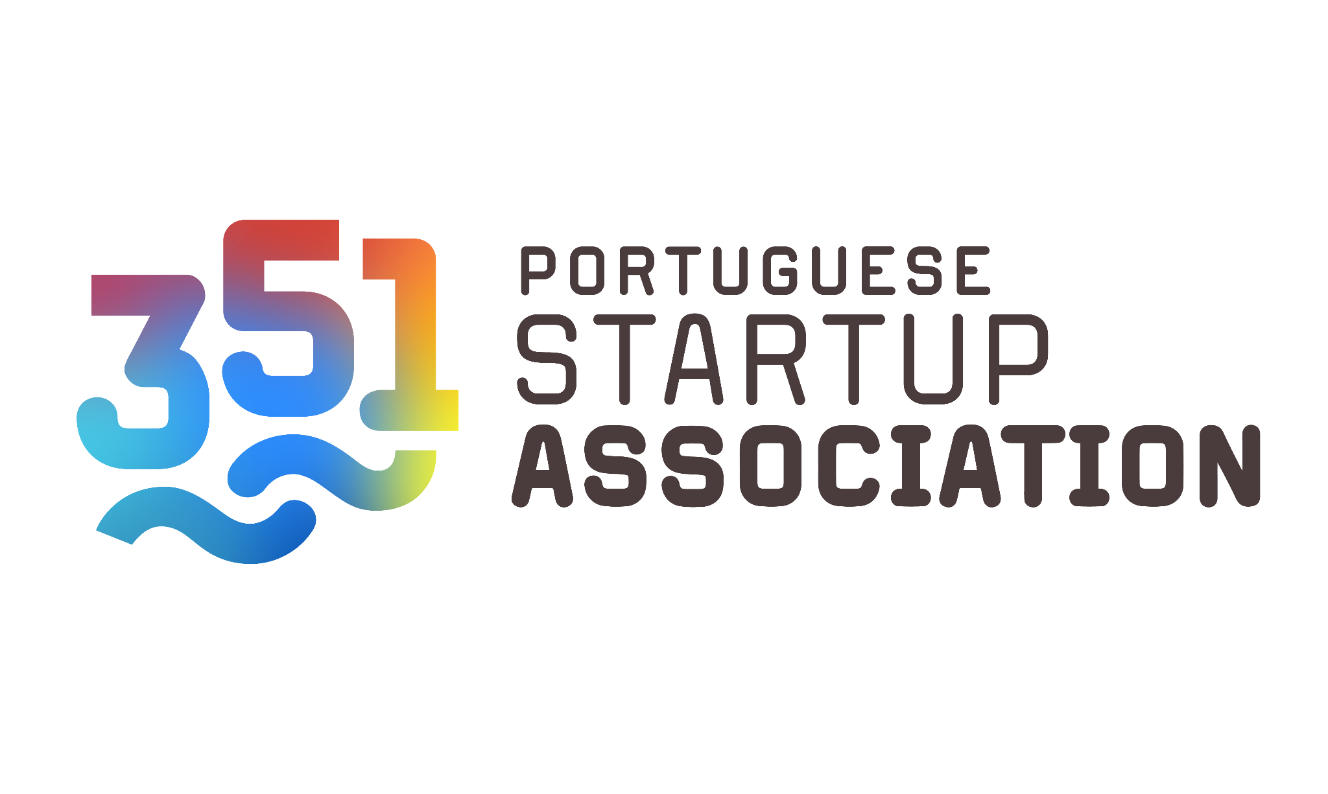



**In alphabetical order:**

351 Portuguese Startup Association, ACT - The App Association, Digital, AustrianStartups, Cro Startups, Czech Founders, Czech Startup Association, Danish Entrepreneurs, Dutch Startup Association, Estech, Estonian Founders Society, France Digitale, Italian Tech Alliance, InnovUp, Latitude59, Local Foundation Rise Europe, Roma Startup, ROTSA, SAPIE, scale-ups.be, Start:up Slovenia, Startup Disrupt, Startup Greece, Startup Hungary, Startup Valencia, SISP, Startup-Verband, Techosystem Ukraine, Unicorns Lithuania.

1. EU Single Market Strategy, 2025
2. EU Startup and Scaleup Strategy, 2025
3. Only ca 10% of the organisations consulted represented startups
4. Mario Draghi, 9 September 2024